CENWP-OD-B 23 September 2010

MEMORANDUM FOR THE RECORD

SUBJECT: Dead chinook at Bonneville’s Adult Fish Facility (AFF).

On 23 September at approximately 1100, CRITFC researchers called Project Fisheries to report two dead chinook in the AFF. The fish were discovered on the Valve 15 return pool drain trash rack while CRITFC was cleaning off debris. Both fish were descaled, but that may be due to process of removing them from the trash rack. The 81cm tagged chinook had previously been sampled by CRITFC in days prior to discovery. The fish were disposed of down drain valve 15 in the AFF at 1145. Information collected is provided below:

- Species – two chinook female
- Origin – unclipped
- Length – 81cm; 82cm
- Marks and tags – 3D9.1C2D415385; none
- Marks and Injuries found on carcass – some descaling on both
- Cause and Time of Death – Unknown
- Future and Preventative Measures – N/A

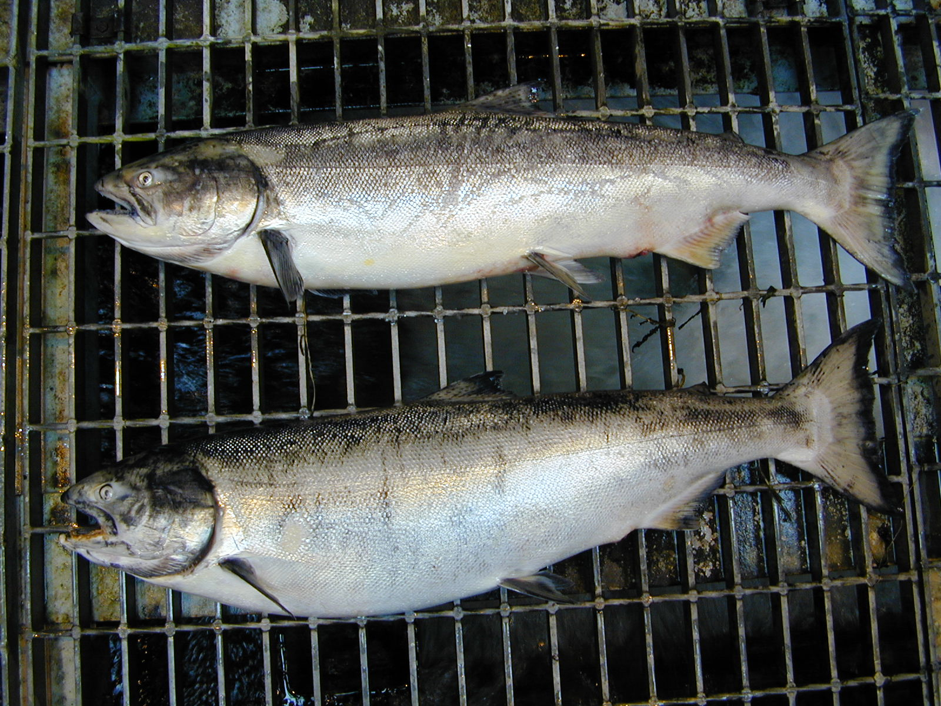

Bonneville Fisheries

